1. A numeric variable to store your age.

Output:

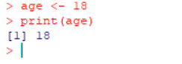

1. A character variable to store your name.

Output:

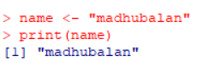

1. A logical variable to indicate if you are a student  
   (TRUE or FALSE).

Output:

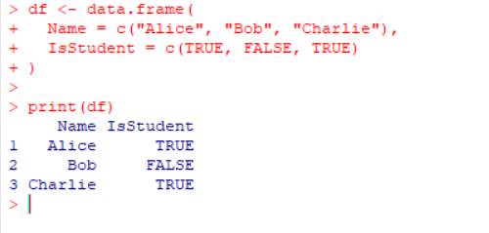

1. A vector containing five numbers of your choice.

Output:

